
UNIT-I INTRODUCTION TO OOP AND JAVA
PART-A
1. Mention some of the separators used in Java programming.
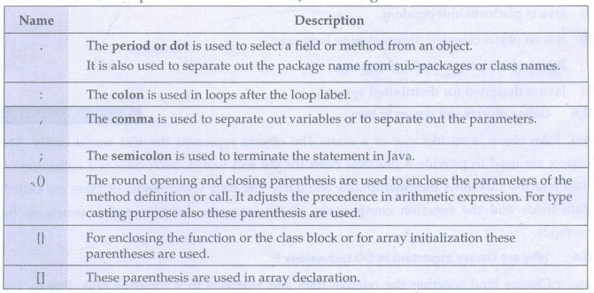
2. How dynamic initialization of variables is achieved in java ?
The variables in Java are allowed to get initialized at run time. Such. type of initialization is called dynamic initialization.
For example
double a=5.0;
double b=20.0
double c=Math.sqrt((a+b));
Here the expression is evaluated at run time and its square root value is calculated and then the variable c is initialized dynamically.

3. What is the output of the main method in the given code?
public static void main(String[] args)
{
screen.write(sum());
}
static int sum()
{
int A=12;
int B=13;
return =A+B;
}
It will generate error at the statement return = A+B as "Illegal start of expression".
4.What are the features of Java ?
1) Java is simple to implement.
2) Java is platform independent.
3) It is an object oriented programming language.
4) It is a robust programming language.
5) Java is designed for distributed system.

5. Define objects and classes in Java.
An object is an instance of a class. The objects represent the real world entity. The objects are used to provide a practical basis for the real world. Each class is a collection of data and the functions that manipulate the data. The data components of class are called data fields and the function components of the class are called member functions or methods.
6. Why are classes important in OO technology?
Classes bind together the relative data and methods in a cohesive unit. Due to this arrangement, only certain methods are allowed to access the corresponding data. Secondly, if any modification is needed, then the class can be viewed as one module and the changes made in one class does not spoil rest of the code. Moreover, finding error from such a source code becomes simple.

7. What is the difference between object and class?
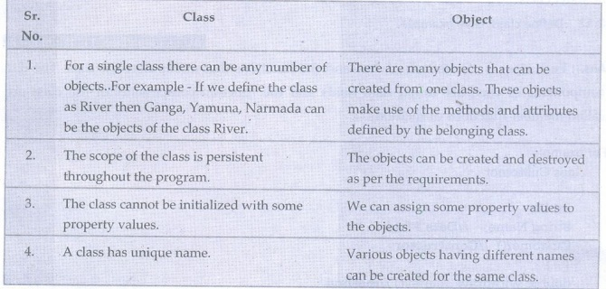
8. What is the difference between structure and class?
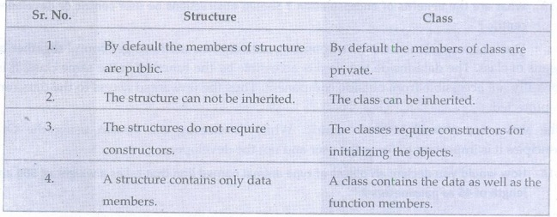
9. What is the difference between static and non static variables?
A static variable is shared among all instances of class, whereas a non static variable (also called as instance variable) is specific to a single instance of that class.

10. Define encapsulation.
Encapsulation means binding of data and method together in a single entity called class.
11. What is an abstract class?
When apply inheritance, the class becomes more and more specific as we move down. Sometimes a situation may occur that the superclass becomes more general and less specific. Such a class lists out only common features of other classes. Such a super class is called as abstract class.
12. Define class. Give example.
Each class is a collection of data and the functions that manipulate the data. The data components of class are called data fields and the function components of the class are called member functions or methods.
class Customer
{
int ID;
String Name; //Data Field
Customer() //Constructor
{ }
double withdraw money() //method {...}
}
13. What are the benefits of encapsulation? Should abstractions be user centric or developer- centric?
Due to encapsulation the corresponding data and the methods get bound together by means of class. The data inside the class is accessible by the function in the same class. It is normally not accessible from outside component. Thus the unwanted access to the data can be protected.
The abstraction should be user centric. While developing the system using the O0 principles it is important to focus the user and not the developer.

14. How would you declare an object of type animal named lion that takes a weight of 500 and length of 45 as parameters?
public class Animal
{
int weight, length;
Animal(int wt, int len)
{
weight=wt;
length=len;
}
void Show()
{
System.out.println("\n The weight of animal is: "+weight);
System.out.println("\n The length of animal is: "+length);
}
}
class AnimalMain
{
public static void main(String args[]).
{
Animal Lion=new Animal(500,45);
Lion.Show();
}
}
Output
The weight of animal is: 500
The length of animal is: 45
15. What is meant by private access specifier?
The private access specifier allows classes, methods and data fields accessible only from within the own class. The functions outside the class cannot access the data members or the member functions.
16. What do you mean by instance variable?
An Object is an instance of a class. The variables that the object contains are called instance variables. For example consider a class Student
class Student
{
int RollNo;
char name[10];
}
Student S; //Creation of object of type Student class.
S= new Student();
If we create an object of the class Student say S, then using this object the variables RollNo and name can be accessed. These variables that belong to object S are then called as instance variables. Thus the Instance variables are any variables, without "static" field modifier, that are defined within the class body.
17. Define constructor.
Constructor is a specialized method used for initializing the objects. The name of this method and the name of the class must be the same. The constructor is invoked whenever an object of its associated class is created.
18. What is Static in Java?
In java, static is a member of a class that is not associated with an instance of a class. If there is a need for a variable to be common to all the objects of a single java class, then the static keyword should be used in the variable declaration.
19. What is the difference between a constructor and a method?
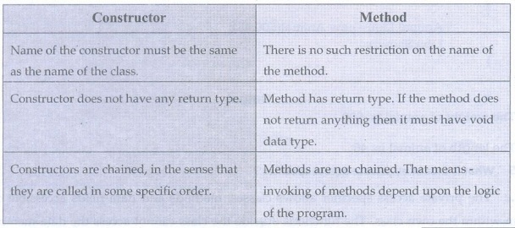

20. What are key characteristics of objects?
1. Object is an instance of a class.
2. Objects are runtime entities.
3. Using object of a class the member variable and member functions of a class can be accesses.
21. What is meant by parameter passing constructors? Give example.
The constructor methods to which the parameter are passed are called parameter passing constructors
Example -
Rectangle (int h,int w)
{
height=h;
weight=w;
}
22. Enumerate two situations in which static methods are used.
1) The situation in which object of belonging class is not created and we want to use the method of that class, then the method must be static.
2) For calling another static method, one such static method is used.
3) For accessing static data the static method must be used.

23. List any four Java Doc comments.
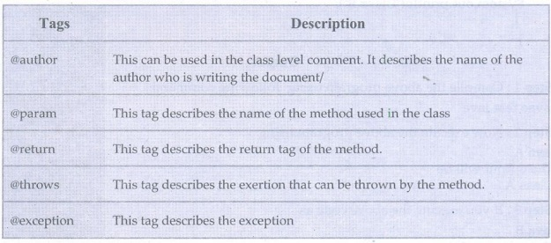
24. What is the need for javadoc multiline comments?
Javadoc multiline comments can be used to document all java source code. Comments follow a standard format consisting of a description followed by block tags. The first sentence of the description should be clear and concise as it is used in the summary of the API item.
25. Define access specifier.
Access Specifier is used to set the accessibility of class members. There are three access specifiers in Java - (1) Public (2) Private (3) Protected.
26. What is Javadoc ?
The Javadoc is a standard way to comment the java code. It has a special format of commenting the java code.
27. Can Java source file be saved using a name other than the class name. Justify.
we can save the java source file using a name other than the class name. But we should compile the program with file name and should run the program with the class name in which the main methods exist. And there must not be any public class defined inside this java source file. For example, consider following Java code which is saved using the file name test.java
class A
{
public static void main(String args[])
{
System.out.println("Class A");
}
}
class B
{
public static void main(String args[])
{
System.out.println("Class B");
}
}
Output
Step 1: Compile the above program using following command
javac test.java
Step 2: Now execute the above program using
java A
The output will be
Class A
Step 3: If you execute the above code as
java B
The output will be
ClassB

UNIT-II INHERITANCE, PACKAGES AND INTERFACES
PART-A
1 .Define the term inheritance.
Inheritance is a mechanism in which the derived class borrows the properties of the base class.
2 .Explain the use of extend keyword with suitable example.
• The extend keyword is used in inheritance.
• When the child class is derived from its parent class then the keyword extends is used.
3 .What is the difference between super class and subclass?
• The superclass is a parent class or base class from which another class can be derived.
• The subclass is always a derived class which inherits the properties of the base class or superclass.
• The superclass is normally a generalized class whereas the subclass is normally for specific purpose.

4. Enlist various forms of inheritance.
Various forms of inheritance are -
1. Single level inheritance
2. Multiple inheritance
3. Multi-level inheritance
4. Hierarchical inheritance
5. Hybrid inheritance
5. What is the use of super keyword ?
The super class is used to access immediate parent class from the subclass. It is used to
1. access parent's variable,
2. access parent's method
3. access patent's constructor invocation
6. Differentiate between inheritance and polymorphism.
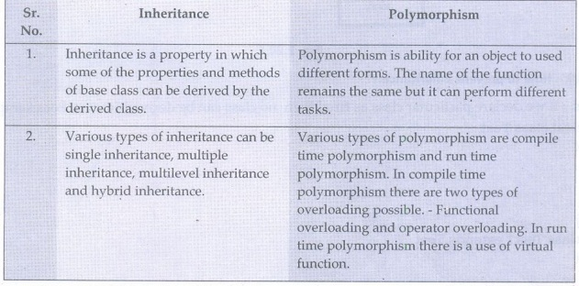
7. Distinguish between static and dynamic binding.
Static binding is a type of binding in which the function call is resolved at compile time. The dynamic binding is a type of binding in which the function call is resolved at run time. The static binding is called the early binding and the dynamic binding is called late binding.
8. What is the purpose of 'final' keyword ?
The keyword 'final' is used to avoid further modification of a variable, method or a class. For instance if a variable is declared as final then it can not be modified further, similarly, is a method is declared as final then the method overriding is avoided.
9. Define inheritance hierarchy.
The inheritance hierarchy represents the collection of classes the inherit from their base classes and thereby make use of the code present in the base class. The data reusability can be achieved by inheritance hierarchy. For example
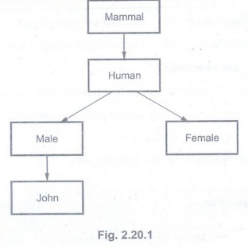
10. How to prevent inheritance?
If we declare particular class as final then no class can be derived from it. For example
final class Test
{
………..
………
……….
}
class Test1 extends Test
{
………..
………
……….
}
The above code will produce an error" cannot inherit from final Test".
Thus the use of keyword final for the class prevents the inheritance.
11. Write a class declarations for the following relationship, assuming that all classes are public: a Bulldog is a kind of dog, and a Dog is a kind of Animal.
class Animal
{
………….
}
class dog extends Animal
{
………...
}
class Bulldog extends dog
{
…………..
}
12. What is meant by dynamic method dispatch?
. The dynamic method dispatch is run time polymorphism in which a call to overridden function is resolved at runtime instead of at compile time. Hence is the name. For example
class Test1
{
public void method1()
{ }
}
class Test2 extends Test1
{
public void method1()
{ }
}
void main()
{
Test1 obj=new Test2();
obj.method1();
}
13.Can an abstract class be final? Why?
The abstract class cannot be final because once we declared the abstract base class with the keyword final then it can not be inherited.
14. Can an abstract class in Java be instantiated? Give the reason.
The abstract class can not be instatiated (i.e. we can not create the object of this class using new operator) because the abstract class is very much general and less specific. It does nothing and simply lists out only common features of other classes.
15. Why is multiple inheritance using classes a disadvantage in Java?
In multiple inheritance, the child class is derived from two or more parent classes. It can lead to ambiguity when two base classes implement a method with the same name. State the condition for method overriding in Java
Method overriding occurs only when the name of the two methods(method in super class and method in subclass) are same and their type signature is same.

17.What is package?
Package represent a collection of classes, methods and interfaces. The name of the package must be written as the first statement in the Java source program. The syntax of specifying the package in the Java program is
package name_of_package
Due to package the systematic arrangement of classes is possible. All standard classes in Java are stored in named packages.
18. Mention the necessity for import statement.
The import statement is used to refer the classes and methods that are present in particular package. This statement is written at the beginning of any Java program. For example -
import java.io.*
This statement allows to use the useful functionalities for performing input and output operations.
19. List any four packages in java and highlight their features.
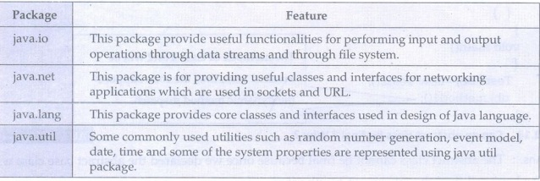
20. What is API package?
The API packages are application programming interface packages used by java.
• These packages include important classes and interfaces which are used by the programmer while developing the java applications.
• For example java.io, java.util, java.net and so on are the commonly used API.
21. Explain any three uses of package.
1.The classes defined in the packages of other program can be easily reused.
2. Two classes from two different packages can have the same name. By using the package name the particular class can be referred.
3. Packages provide the complete separation between the two phases- design and coding.
22. Explain the term CLASSPATH.
Ans. The packages are nothing but the directories. For locating the specified package the java run time system makes use of current working directory as its starting point. This directory path is called CLASSPATH.
23. What are the ways of importing the java packages? OR Write the syntax for importing packages in a Java source file and give an example.
The import statement can be written at the beginning of the Java program, using the keyword import. For example -
import java.io.File
or
import java.io.*
Either a class name can be specified explicitly or a * can be used which indicated that the Java compiler should import the entire package.
24. In Java what is the use of interface?
OR What is interface mention its use.
In java, the interface is used to specify the behaviour of a group of classes. Using interfaces the concept of multiple inheritance can be achieved.
25. Define Interface and write the syntax of the Interface.
The interface can be defined using following syntax access_modifier interface name_of_interface
{
return_type method_name1(parameter1,parameter2,...parametern);
…………
return_type method_name1(parameter1,parameter2,...parametern);
type static final variable_name=value;
………...
}
The interface is a collection of various methods that can be used by the class that is attached to the interface. The interface name must be preceded by the keyword interface.
26. What modifiers may be used with an interface declaration ?
Ans. : An interface may be declared as public or abstract.
27. Why the variables in interface static and final ?
Ans. The members of interface are static and final because -
1) The reason for being static - The members of interface belong to interface only and not object.
2) The reason for being final - Any implementation can change value of fields if they are not defined as final. Then these members would become part of the implementation. An interface is pure specification without any implementation.
28. What is the purpose of nested interface?
The nested interfaces are used to group related interfaces so that they can be easy to maintain. The nested interface must be referred by the outer interface or class. It can't be accessed directly.
29. What are the properties of nested interface?
1) Nested interfaces are static by default. You don't have to mark them static explicitly.
2) Nested interfaces declared inside class can take any access modifier.
3) Nested interface declared inside interface is public implicitly.
30. If a class B is derived from class A and extends the interface myinterface, then how will you write this statement for class B definition?
class B extends class A implements my interface
{
....//body of class B
}

UNIT–III EXCEPTION HANDLING AND MULTITHREADING
1 What is an exception? Give example.
Exception is a mechanism which is used for handling unusual situation that may occur in the program.
For example -
Arithmetic Exception: This exception is used to handle arithmetic exceptions such as divide by zero,
IO Exception: This exception occurs when an illegal input/output operation is performed.
2. What will happen if an exception is not caught?
An uncaught exception results in invoking of the uncaught Exception () method. As a result eventually the program will terminate in which it is thrown.
3. What is the benefit of exception handling?
When calling method encounters some error then the exception can be thrown. This avoids crashing of the entire application abruptly.
4. What is the difference between error and exception in java?
Errors are mainly caused by the environment in which an application is running. For example, OutOfMemoryError happens there is shortage of memory. Where as exceptions are mainly caused by the application itself. For example, NullPointerException occurs when an application tries to access null object.
5. What is compile time and run time error?
1. The errors that are detected by the Java compiler during the compile time are called compiler time errors.
2. The runtime errors are basically the logically errors that get caused due to wrong logic.
6. what is the use of try, catch keywords?
try - A block of source code that is to be monitored for the exception.
catch - The catch block handles the specific type of exception along with the try block.
7. What is the difference between throw and throws?
1. The throw keyword is used to explicitly throw an exception.
2. The throws keyword is used to declare an exception.
8. What is Array Index Out Of Bounds Exception?
When we use an array index which is beyond the range of index then Array Index out of Bounds Exception occurs.
9. what is the need of multiple catch?
• There may be the situations in which different exceptions may get raised by a single try block statements and depending upon the type of exception thrown it must be caught.
• To handle such situation multiple catch blocks may exist for the single try block
statements.
10. There are three statements in a try block - statement1, statement2 and statement3. After that there is a catch block to catch the exceptions occurred in the try block. Assume that exception has occurred in statement2. Does statement3 get executed or not?
No. Once a try block throws an exception, remaining statements will not be executed. Control comes directly to catch block.

11. Explain the types of exceptions.
There are two types of exceptions:
1. Checked Exception: These types of exceptions need to be handled explicitly by the code itself either by using the try-catch block or by using throws. These exceptions are extended from the java.lang.Exception class.
For example: IOException which should be handled using the try-catch block.
2. Unchecked Exception: These type of exceptions need not be handled explicitly. The Java Virtual Machine handles these type of exceptions. These exceptions are extended from java.lang.RuntimeException class.
For example: ArrayIndexOutOfBounds, NullPointerException, RunTimeException.
12. Does finally block get executed If either try or catch blocks are returning the control?
Yes, finally block will be always executed no matter whether try or catch blocks are returning the control or not.
13. Can we have empty catch block?
Yes we can have empty catch block, but it is an indication of poor programming practice. We should never have empty catch block because if the exception is caught by that block, we will have no information about the exception and it will create problem while debugging the code.\
14. Which class is the super class for all types of errors and exceptions in java ?
The java.lang.Throwable is the super class for all types of errors and exceptions in java.
15. What is runtime exceptions?
RuntimeException is the superclass of those exceptions that can be thrown during the normal operation of the Java Virtual Machine. Runtime Exception is the parent class in all exceptions of the Java.
16. What is exception handling?
Exception handling is a mechanism in which the statements that are likely to cause an exception are enclosed within try block. As soon as exception occurs it is handled using catch block.
Thus exception handling is a mechanism that prevents the program from crashing when some unusual situation occurs.
17. What happens when the statement int value = 25/0 is executed?
The exception Arithmetic Exception: Divide by zero will occur.
18. What do you mean by threads in Java ?
Thread is tiny program running continuously. It is a light weight process in Java..
19. Give the difference between process and thread.
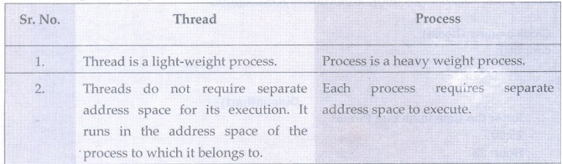
20.What are different stages in thread?
Various stages in thread are
1. New state
2. Time waiting state
3.Runnable state
4. Waiting state
5.Blocked state 6. Terminated state
21. What do you mean by synchronization ?
When two or more threads need to access shared memory, then there is some way to ensure that the access to the resource will be by only one thread at a time. The process of ensuring one access at a time by one thread is called synchronization.
22. What are the three ways by which the thread can enter in waiting stage?
i) Waiting state: Sometimes one thread has to undergo in waiting state because another thread starts executing. This can be achieved by using wait() state.
ii) Timed waiting state: There is a provision to keep a particular threading waiting for some time interval. This allows to execute high prioritized threads first. After the timing gets over, the thread in waiting state enters in runnable state. This can be achieved by using the sleep() command.
iii) Blocked state : When a particular thread issues an input/output request then operating system sends it in blocked state until the I/O operation gets completed. After
the I/O completion the thread is sent back to the runnable state. This can be achieved by using suspend() method.
23. What is multithreading?
Multithreading is an environment in which multiple threads are created and they can execute simultaneously. The multiple threads can be created either by extending the thread class or by implementing the runnable interface.
24. Mention two mechanisms for protecting a code block from concurrent access.
There are two mechanisms for protecting a code block from concurrent access -
1. Use of reentrant code
2. Use synchronized block
25. What is meant by notify methods in multithreading?
The notify() method is used for inter thread communication. If a particular thread is in the sleep mode then that thread can be resumed by using the notify call.
26. What are the two ways of creating a thread?
Thread can be created using
1. Thread class 2. runnable interface.
27. Why do we need run() and start() method both? Can we achieve it with only run() method?
We use start() method to start a thread instead of calling run() method because the run() method is not a regular class method. It should only be called by the JVM. If we call the run() method directly then it will simply invoke the caller's thread instead of its own thread. Hence the start() method is called which schedules the thread with the JVM.
28. What is the need for thread?
In Java threads are used to handle multiple tasks together. This kind of programming is called concurrent programming.
29. Name any four thread constructor.
1. Thread()
2. Thread(String name).
3. Thread(Runnable target)
4. Thread (Runnable target, String name)
30. When thread is initiated and created, what is its initial stage?
A thread is in "Ready" state after it has been created and started. This state signifies that the thread is ready for execution. From here, it can be in the running
state.
31. "Thread is a lightweight process" - Comment
Threads do not require separate address for its execution. It runs in the address space of the process to which it belongs to. Hence thread is a lightweight process.
32. Sketch the life cycle of thread
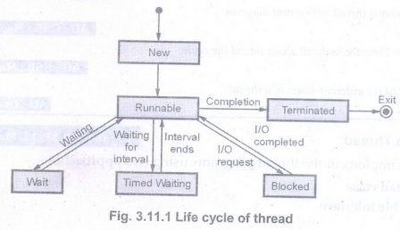

UNIT-IV I/O, GENERICS, STRING HANDLING
1. What is stream?
Stream is basically a channel on which the data flow from sender to receiver.
2 .What is input stream and output stream?
An input object that reads the stream of data from a file is called input stream and the output object that writes the stream of data to a file is called output stream.
3. What is byte stream? Enlist its super classes.
The byte stream is used for inputting or outputting the bytes. The Input Stream and Output Stream are the super class of byte stream.
4. What is character stream? Enlist its super classes.
The character stream is used for inputting or outputting the characters. The Reader and Writer are the superclass of character stream.
5. List the byte stream classes.
The Byte Stream classes are -
1. File Input Stream
3. Filter Input Stream
5. File Output Stream
7. Filter Output Stream
2. Piped Input Stream
4. Byte Array Input Stream
6. Piped Output Stream
8. Byte Array Output Stream
6. What is the purpose of Buffered Input Stream and Buffered Output Stream classes?
• These are efficient classes used for speedy read and write operations.
• We can specify Buffer size while using these classes.
7. Give an example on stream.
• There are two types of streams - Byte stream and Character stream.
• Stream classes for byte stream: File Input Stream, Piped Input Stream, Buffered Input Stream, File Output Stream, Piped Output Stream and so on.
• Stream classes for character stream: File Reader, Pipe Reader, Buffered Reader, File Writer, Pipe Writer, Buffered Writer and so on.
8. What is absolute file name?
The filename that can be specified with the complete path name and drive letter is called absolute file name.
9. What is relative file name?
The file name which is specified as a path relative to the current directory is called relative file name. For example new File("myprogram.html");
10. What is the use of seek method?
The seek() allows you to specify the index from where the read and write operations will start. The syntax is
void seek(long position);

11. Write a Java code to check if the command line argument is file or not.
class Test
{
public static void main(String[] args)
{
File obj=new File(args[0]);
If(obj.isFile())
{
System.out.println("This is a file name" + obj.getPath());
}
}
}
12. Enlist the two common constructors of File Input Stream.
The common constructors of File Input Stream are
File Input Stream (String filename);
File Input Stream (File file object);
13. What is the use of Input Stream Reader and Output Stream Writer?
The Input Stream Reader converts byte into character and OutputStreamWriter converts the characters written into byte.
14. Give an example for reading data from files using FileInput Stream
import java.io.FileInputStream;
public class test
{
public static void main(String args[])
{
try
{
FileInputStream fin=new FileInputStream("D:\\input.txt");
int i=0;
while((i=fin.read())!= -1)
{
System.out.print((char)i);
}
fin.close();
}catch(Exception e) { System.out.println(e);}
}
}
15. Why generic programming is required?
OR What is the need for generic programming?
Following some reasons for the need of generic programming -
1. It saves the programmers burden of creating separate methods for handling data belonging to different data types.
2. It allows the code reusability.
3. Compact code can be created.
16. List out motivation needed in generic programming.
1. Suppose we want to create a stack and if we create a stack of integers then it will store only the integer elements, if we try to push any string or any double type element then a compile time error will occur. If we want to push any string then we need to create a separate stack, separate class and separate methods for handling the String elements. Same is true for the elements of any other data type. This results in complex code building. To avoid such complexity, a concept of generic programming is introduced.
2. It saves the programmers burden of creating separate methods for handling data belonging to different data types.
3.It allows the code reusability..
4. Compact code can be created.
17. With an example define a generic class. Or Describe generic classes.
A generic class contains one or more variables of generic data type. Following is a simple example which shows how to define the generic class.
public class Test<T>
{
public Test(){val=null;}
public Test(T val)
{
this.val=val;
}
public getVal()
{
return val;
}
public setVal()
{
val=newValue;
}
private T val; //variable defined as of generic type
}

18. Can generic be used with inheritance in several ways? What are they?
Following are the ways by which generic can be used with inheritance -
• Consider a class and a subclass such as Employee and Trainee. There are two pair classes Pair<Employee> and Pair<Trainee> which do not possess an inheritance relation. That is, Pair<Trainee> is not a subclass of Pair<Employee> even if these two classes are related to each other.
• The parameterized raw type can be converted to a raw type.
• The generic classes can extend to implement other generic classes.
19. List any two advantages of type parameters.
1.Due to the use of type parameter it saves the programmers burden of creating separate methods for handling data belonging to different data types.
2. Due to type parameter the early error detection at compile time occurs. This avoids crashing of the code (due to type incompatibility) at run time.
20. State any two challenges of generic programming in virtual machine.
i) The virtual machine does not work with generic classes or generic methods. Instead it makes uses raw types in which the raw types are replaced with ordinary java types. Each type variable is replaced with its bound or with object, if it is not bounded. This technique is called type erasure.
ii) In order to handle the type erasure methods the compiler has to generate bridge methods in corresponding class.

UNIT-V JAVAFX EVENT HANDLING, CONTROLS AND COMPONENTS

1.What is JavaFX?
JavaFX is a set of graphics and media packages that enable developers to design, create, test, debug and deploy rich client applications that operate consistently across different platforms.
JavaFX makes it easier to create desktop applications and games in Java.

2. What are various features of JavaFX ?
1) JavaFX library is written in java. Hence developer find it easy to learn and write the applications in JAVAFX.
2) JAVAFX library creates UI controls using which any GUI based application can be developed.
3) It provides the classes for 2D and 3D graphics.
4) JavaFX contains a set of ready-to-use chart components, so you don't have to code that from scratch every time you need a basic chart.

3 What are the main components of JavaFX application?
Every JAVAFX program is divided into three main components - Stage, Scene and Node and Scene graph.
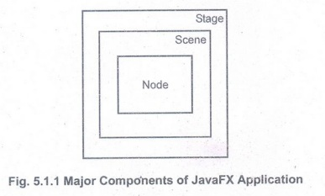

4. Which method is used to launch JavaFX application?
The launch() method is used to launch JavaFX application.

5. Which method is used in which we write the code for JavaFX application?
The start() method is used in which we write the code for JavaFX application.

6. Explain the terms - Stage and scene used in JavaFX application.
1) Stage: Stage is like main frame of the program. It acts as a container for all the objects of JavaFX application. The most commonly used stage is a PrimaryStage.
2) Scene: The Javafx.scene.Scene class provides the methods to deal with the scene object. It contains the nodes or all the contents of Scene graph.

7. Explain the terms - Scene graph and node used in JavaFX.
1) The scene graph is a collection of various nodes.
2) The node is an element that can be visualized on the screen. The node can be button, textbox, radio button and so on.

8. What is the use of pane in JavaFX application?
Pane is a container class using which the UI components can be placed at any desired location with any desired size.
Generally you place a node inside a pane and then place pane into a scene. Actually node is any visual component such as UI controls, shapes, or a image view.

9. What is property binding in JavaFX ?
Property binding is a technique that enables target object to bind with the source object. Due to this mechanism, when the value in source object changes then the target property also changes automatically
.
10. What is Event?
Event means any activity that interrupts the current ongoing activity.
For example: When user clicks button then it generates an event. To respond to button click we need to write the code to process the button clicking action.

11. What is event source object?
The object that generates the event is called event source object. For example - If the event gets generated on clicking the button, then button is the event source object.

12. Explain the terms - event handler and event listener.
Event Handler: The event handling code written to process the generated event is called event handler.
Event Listener: The task of handling an event is carried out by event listener. When an event occurs, first of all an event object of the appropriate type is created. This object is then passed to a Listener.

13. Explain the event methods in JavaFX that are associated with keyboard.
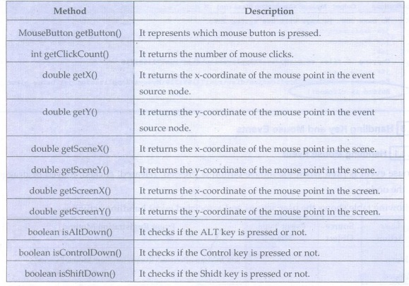

14. Explain any two UI controls used in JavaFX application.
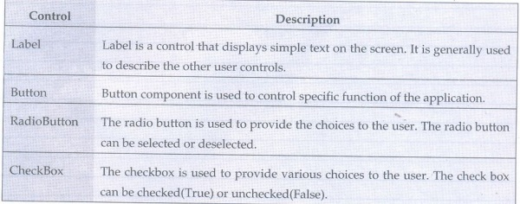
15. What is layout pane?

• The arrangement of various components (nodes) in a scene within the container is called layout of the container.
• For using the layout we must import the package javafx.scene.layout. The class named Pane is the base class for all the layouts in JavaFX.

16.Enlist various layout panes used in any JavaFX application?
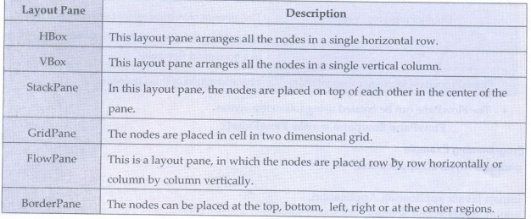

17. Explain the terms - Menu bar and Menu item.

• Menu Bar is just like a navigation bar with menus on it. The menu bar is located at the top of the screen.
• A Menu Item is a basic item that goes on a menu.

